모바일프로그래밍 과제02 컴퓨터소프트웨어공학과 2-YA 20202296 전채린

01. HelloWorld

[소스코드]

activity_main.xml

<?xml version="1.0" encoding="utf-8"?>  
<RelativeLayout xmlns:android="http://schemas.android.com/apk/res/android"  
 xmlns:app="http://schemas.android.com/apk/res-auto"  
 xmlns:tools="http://schemas.android.com/tools"  
 android:id="@+id/relativetLayout"  
 android:layout_width="match_parent"  
 android:layout_height="match_parent"  
 tools:context=".MainActivity">  
  
 <TextView  
 android:id="@+id/textView"  
 android:layout_width="wrap_content"  
 android:layout_height="wrap_content"  
 android:layout_alignParentStart="true"  
 android:layout_alignParentLeft="true"  
 android:layout_alignParentTop="true"  
 android:layout_centerInParent="true"  
 android:layout_marginStart="183dp"  
 android:layout_marginLeft="183dp"  
 android:layout_marginTop="325dp"  
 android:text="Hello World!"  
 app:layout_constraintBottom_toBottomOf="parent"  
 app:layout_constraintLeft_toLeftOf="parent"  
 app:layout_constraintRight_toRightOf="parent"  
 app:layout_constraintTop_toTopOf="parent" />  
  
 <Switch  
 android:id="@+id/switch2"  
 android:layout_width="wrap_content"  
 android:layout_height="wrap_content"  
 android:layout_alignParentTop="true"  
 android:layout_alignParentEnd="true"  
 android:layout_alignParentRight="true"  
 android:layout_centerInParent="true"  
 android:layout_marginTop="219dp"  
 android:layout_marginEnd="155dp"  
 android:layout_marginRight="155dp"  
 android:text="Switch" />  
  
 <CheckBox  
 android:id="@+id/checkBox2"  
 android:layout_width="wrap_content"  
 android:layout_height="wrap_content"  
 android:layout_alignParentTop="true"  
 android:layout_alignParentEnd="true"  
 android:layout_alignParentRight="true"  
 android:layout_centerHorizontal="true"  
 android:layout_marginTop="113dp"  
 android:layout_marginEnd="153dp"  
 android:layout_marginRight="153dp"  
 android:text="CheckBox" />  
  
 <RatingBar  
 android:id="@+id/ratingBar2"  
 android:layout_width="wrap_content"  
 android:layout_height="wrap_content"  
 android:layout_alignParentEnd="true"  
 android:layout_alignParentRight="true"  
 android:layout_alignParentBottom="true"  
 android:layout_marginEnd="72dp"  
 android:layout_marginRight="72dp"  
 android:layout_marginBottom="139dp" />  
  
 <SeekBar  
 android:id="@+id/seekBar"  
 android:layout_width="wrap_content"  
 android:layout_height="wrap_content"  
 android:layout_alignParentBottom="true"  
 android:layout_centerHorizontal="true"  
 android:layout_marginBottom="90dp" />  
  
</RelativeLayout>

MainActivity.kt

package kr.ac.dongyang.helloandroid  
  
import androidx.appcompat.app.AppCompatActivity  
import android.os.Bundle  
  
class MainActivity : AppCompatActivity() {  
  
 override fun onCreate(savedInstanceState: Bundle?) {  
 super.onCreate(savedInstanceState)  
 setContentView(R.layout.activity_main)  
 }  
}

[실행결과]

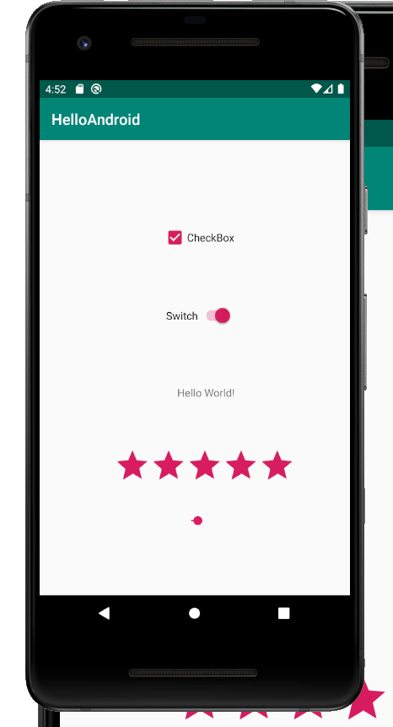

02. BaseApp

[소스코드]

activity_main.xml

<?xml version="1.0" encoding="utf-8"?>  
<LinearLayout xmlns:android="http://schemas.android.com/apk/res/android"  
 xmlns:app="http://schemas.android.com/apk/res-auto"  
 xmlns:tools="http://schemas.android.com/tools"  
 android:layout_width="match_parent"  
 android:layout_height="match_parent"  
 android:orientation="vertical"  
 tools:context=".MainActivity">  
  
 <Button  
 android:id="@+id/button1"  
 android:layout_width="match_parent"  
 android:layout_height="wrap_content"  
 android:text="버튼입니다."></Button>  
  
 <Button  
 android:id="@+id/button2"  
 android:layout_width="match_parent"  
 android:layout_height="wrap_content"  
 android:text="버튼2"></Button>  
  
</LinearLayout>

MainActivity.kt

package aca.dongyang.baseapp  
  
import androidx.appcompat.app.AppCompatActivity  
import android.os.Bundle  
import android.widget.Button  
import android.widget.Toast  
import kotlinx.android.synthetic.main.activity_main.*  
  
class MainActivity : AppCompatActivity() {  
 // lateinit var button1 : Button  
 override fun onCreate(savedInstanceState: Bundle?) {  
 super.onCreate(savedInstanceState)  
 setContentView(R.layout.*activity_main*)  
 // button1 = findViewById<Button>(R.id.button1)  
  
 button1.setOnClickListener **{** Toast.makeText(*applicationContext*, "버튼을 눌렀어요",  
 Toast.*LENGTH_LONG*).show()  
  
 button2.setOnClickListener **{** Toast.makeText(*applicationContext*, "두번쩨 버튼이 눌러졌어요..", Toast.*LENGTH_SHORT*).show()  
 **}  
 }** }  
}

[실행결과]

